Saturday
3.15 pm Theme workshops
8.30 pm Evening Prayer: Service of Light with candles to celebrate the Easter mystery
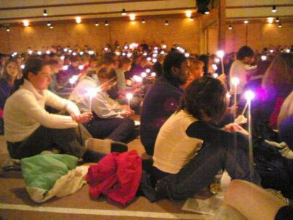
Sunday
8.45 am Breakfast
10 am Sunday Eucharist

My favourite part was the prayers that we had in the morning, midday and evening. Thousands of people in church singing the chants and praying. I enjoyed the ten minute silences as you had time just with yourself and God. It was great meeting new people from all over the world with different cultures and ways of communicating with each other.
Brendan , 15
Trip details and costs
We depart from Xxxxxxx on Saturday xxxxxxx and return on xxxxxxx . We will be travelling by coach.
Cost inclusive of travel, accommodation and food will be £xxx. You will need a valid UK passport, and a European Health Insurance Card.
We shall be camping, so bring a sleeping-bag and camping mat. There are shower and washing facilities on site. It can be hot in France at that time of year, but it can also rain. Come prepared!
Interested?
If you would like more information, or have questions regarding Taizé or the trip, please contact xxxxxxxxxx
xxxxxx xxx xxxxxxxxxxx
To reserve a place please email for a booking form. Those under 18 at the time of travel need to have parent/guardian consent (form available).
Places on the trip are secured by a non-refundable deposit of £xx, paid by the end of xxxx. The balance needs to be paid by xxxxxx.
Read up on Taizé at: www.taize.fr
(This document is downloadable from the page
http://www.taize.fr/schools)

[School or diocesan logo ...]

Taizé Experience
xx - xx (June)July 20xx

For Young People aged 15+
Taizé in France is an extraordinary place – quite different from anywhere else. Someone once said it combines a religious monastery with the feel of a very large youth camp.
“You may arrive at Taizé behind German and Spanish, Swedish and Czech, French and Polish vehicles. But the spirit of openness, solidarity and encounter overcomes any barriers you might expect.”
During the week we are planning in July we shall be joining students from many UK schools, and young people from all over Europe. Young people of different backgrounds meet at Taizé: those who are Catholic, Orthodox, Anglican, believers of other religions, and those of no faith.
The meetings at Taizé are about searching, listening and thinking about what it means to be a human being, and how we can do something to bring justice, peace and hope to our world.
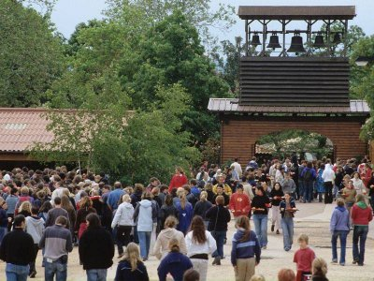
We camp, eat out of plastic bowls, stay up late and spend amazing amounts of time singing and talking and sharing. No one who has been to Taizé comes back unchanged. So why not journey with us and see what there is to discover?
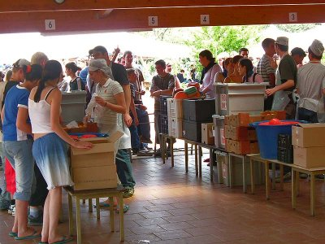

What are the meetings about?

The meetings provide a space where young adults can meet people their age from other countries and talk about important things. But at the same time it is also possible at Taizé to discover how to be on your own.
Three times a day everyone gathers with the community in the church for prayer with songs, a scripture reading and silence.
Each day, the brothers of the community introduce a biblical reflection organised by age and language groups, followed by a time of discussion in small groups.

In the afternoon there workshops which explore themes of faith and life touching on art and culture, social justice, world peace...

Between the meals and times of prayer there is plenty of free time. In the evening there is a great time of socialising at ‘Oyak’ where over refreshments, there is singing, dancing and all kinds of spontaneous entertaininment in the midst of the crowd. And the church is always open for those looking for quiet.
Nothing is compulsory about Taizé. The wonderful sense of freedom there makes the times of prayer and meeting tremendously compelling. You just want to take part in everything because there is so much to be learned and experienced there.
However, Taizé is not a holiday resort. Our trip
is to experience life as part of a faith community. As such, it can be a powerful experience, and we will also be expected to join in and volunteer, for example by serving the meals, washing-up and keeping the site tidy.
A typical day at Taizé
Monday to Friday
8.15 am Morning Prayer, then breakfast
10 am Introduction to the day with a brother of the community followed by small group discussion
12.20 pm Midday Prayer, then lunch
2 pm Optional song-practice during the afternoon international small groups or practical work
5.15 pm Tea
5.45 pm Theme workshops
7 pm Supper
8.30 pm Evening prayer, then vigil with songs in the church, or free time. On Fridays, evening prayer is followed by a vigil around the cross.
9.30 pm Free socialising time at ‘Oyak’
11.30 pm Night silence across the camp.
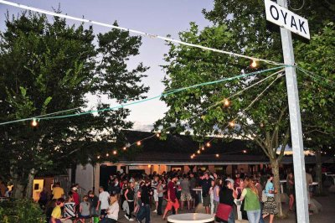
Recreation time at Oyak, Taizé after Evening Prayer

